University Of Engineering and Technology, Lahore
Computer Engineering Department

Course Name: Programming Fundamentals | Course Code: CMPE-112L
Assignment Type: Lab tasks | Dated: 30 March 2026
Semester: First | Session: 2026 Spring
Lab/Project/Assignment #: 1 | CLOs to be covered: CLO 2
Lab Title: Functions | Teacher Name: Hafiz Muhammad Mubashar
Lab Evaluation:

CLO2 | Apply appropriate programming techniques to create executable programs to solve well defined problems
CLO2 | Level1 | Level2 | Level3 | Level4 | Level5 | Level6
(5)
Total |  |  |  |  |  | /5
Rubrics for Current Lab Evaluation
Scale | Marks | Level | Rubric
Excellent | 5 | L1 | Submitted all lab tasks, BONUS task, have good understanding.
Very Good | 4 | L2 | Submitted the lab tasks but have good understanding
Good | 3 | L3 | Submitted the lab tasks but have weak understanding.
Basic | 2 | L4 | Submitted the lab tasks but have no understanding.
Barely Acceptable | 1 | L5 | Submitted only one lab task.
Not Acceptable | 0 | L6 | Did not attempt
Week 5 LAB
Functions
Lab Goals/Objectives:
• To understand the definition, creation, and execution of functions in Python.
• To learn how to pass data into functions using parameters and arguments.
• To master the difference between functions that perform actions (print()) and functions that compute and pass back data (return).
Equipment Required:

* Computer/Laptop
* Python 3.14
* VS Code or pycharm

Theory:
Functions are modular, reusable blocks of code designed to perform a specific task. They help break down complex programs into smaller, manageable, and organized pieces.
Lab Work:

Task 1: Basic Function Definition and Reusability

def a():
print("Hello World")
a()
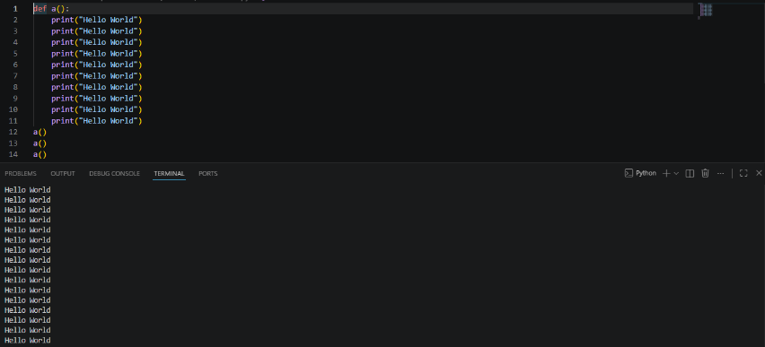
Result:

Task 2: Function with Parameters and Value Returning

def sum (a,b):
return a+b
a=sum(1,3)

Result:
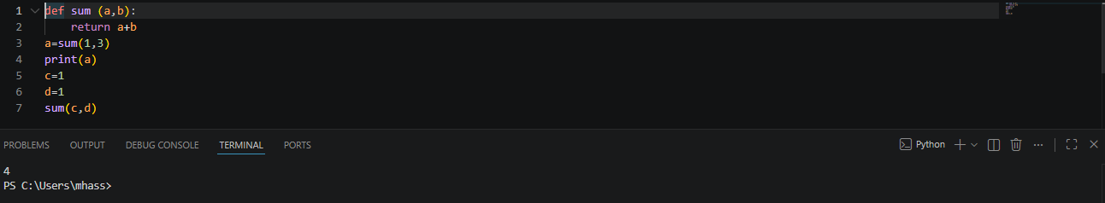

Task 3: Dynamic String Formatting with Arguments

def n(name):
print(f"hello {name},welcome to python class!")
n("Ali")

Result:
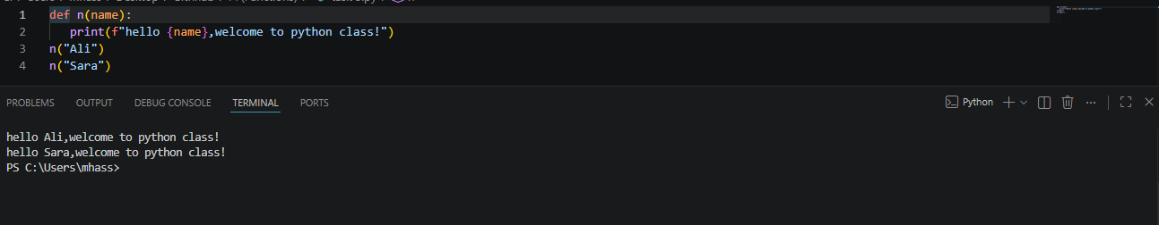

Task 4: Variable Assignment from Function Returns

def sum(a,b):
return a+b
e=sum(c,d)

Result:
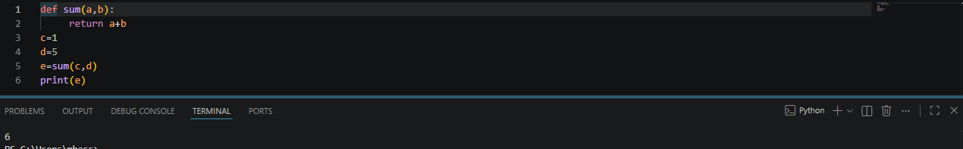

Conclusions:
This lab successfully demonstrates the foundational concepts of procedural abstraction using Python functions. By encapsulating code into reusable blocks, passing dynamic data via inputs, and capturing outputs with the return statement, we established how to eliminate code redundancy and build structured, maintainable software components.

